Multidisciplinary Projects
Class 3: User Experience
Contents
The Importance of the User Experience 2
Terminology 3
Development Processes for User Interfaces 3
The Analyze/Design/Build/Evaluate Loop 3
Tools for Usability Requirements and Evaluation 4
Tools for Usability Requirements: Focus Group 4
Accessibility Requirements 4
Equipment Requirements 4
Design from a System Viewpoint 5
Mental Models 5
Mental Models vs. Computer Model 5
User Interface Design 6
Interface Functions 7
Data and Metadata 7
Computer Systems and Networks 8
Principles of User Interface Design 8
Interface Design: Menus 8
Help System Design 9
Information Presentation 9
Command Line Interfaces 9
Device-Aware Interfaces 10
Networks 10
Smartphones and Tablets: Screen Size 10
Smartphones: Accessibility 11
Screen Size: Responsive Web Design 11
Responsive Web Design 11
User Interface Design: Navigation 12
User Interface Design: Organization of Pages and Screens 12
Organization of screens in a mobile app 13
Navigation: User Testing 13
Mobile Apps: Development Environments 13
Model-View-Controller: The View 14
Model-View-Controller: The Controller 14
Model-View-Controller: The Model 14
Mobile Apps: the Design Challenge 15
Mobile Apps: Development Environments 15
Mobile Apps: Conventions 15
Design Tensions in Web and Mobile Applications 15
Usability and Cost 16
The Analyze/Design/Build/Evaluate Loop 16
Evaluation 16
Evaluation with Users 17
Evaluation with Users: Preparation 17
Usability Laboratory 18
Evaluation with Users: Sessions 18
Evaluation: Number of Users 18
Results Analysis 19
Project: Methodology 19
A Project: Results 19
Evaluation based on Measurement 21
Refining the Design based on Evaluation 22

The Importance of the User Experience
- A computer system is only as good as the experience it provides to its users. If a system is hard to use:
  - users may fail to find important results, or misinterpret what they do find
  - users may give up in disgust
- Appropriate functionality, easy navigation, elegant design, and fast response times make a measurable difference to a system’s effectiveness
- Usability is more than user interface design.
- Good support for users is more than a cosmetic flourish
- Developing good user interfaces needs skill and time.

Terminology
- The user experience is the total of all the factors that contribute to the usability (or otherwise) of a computer and its systems.
- Human Computer Interaction (HCI) is the academic discipline that studies how people interact with computers.

Development Processes for User Interfaces
- It is almost impossible to specify an interactive or graphical interface in a textual document.
  - Requirement benefit from sketches, comparison with existing systems, etc.
  - Designs should include graphical elements and benefit from a mock-up or other form of prototype.
  - User interfaces must be tested with users. Expect to change the requirements and design as the result of testing.
  - Schedules should include user testing and time to make changes.
- Whatever process you use to develop a software system, the development of the user interface is always iterative.

The Analyze/Design/Build/Evaluate Loop

Tools for Usability Requirements and Evaluation

Tools for Usability Requirements: Focus Group
- A focus group is a group interview
  - Interviewer
- Potential users
  - Typically 5 to 12
  - Similar characteristics (e.g., same viewpoint)
- Structured set of questions
  - May show mock-ups
  - Group discussions
- Repeated with contrasting user groups

Accessibility Requirements
- Software designers must be prepared to users with disabilities (e.g., poor eyesight, lack of hearing, poor manual dexterity), or limited knowledge of English, etc.
- Requirements about accessibility are most likely to arise in the user interface.
- You may have a legal requirement to support people with disabilities.

Equipment Requirements
- There may also be requirements to support computers with poor performance, limited screen sizes, bad network connections, etc.
- Be explicit about the equipment assumptions that you make and how to handle failures. Do user testing with both good and bad equipment.
- Example: MacMail has a requirement that operations terminate cleanly if the network connection is lost, but its behavior is erratic if the network connection becomes extremely slow, e.g., it will not quit.

Design from a System Viewpoint

Mental Models
- A mental model is what a user thinks is true about a system, not necessarily what is actually true.
- A mental model should be similar in structure to the system that is represented.
- A mental model allows a user to predict the results of his/her actions.
- A mental model is simpler than the represented system. It includes only enough information to allow reasonable predictions.
- A mental model is also called a conceptual model.
- The mental model is the user's model of what the system provides.
- The computer model may be quite different from the user’s mental model.
- Example: the desktop metaphor
- mental model — one vast collection of pages, which are searched on request
- computer model — a central index, which is searched on request
- Example: web search
- mental model — one vast collection of pages, which are searched on request
- computer model — a central index, which is searched on request

Mental Models vs. Computer Model
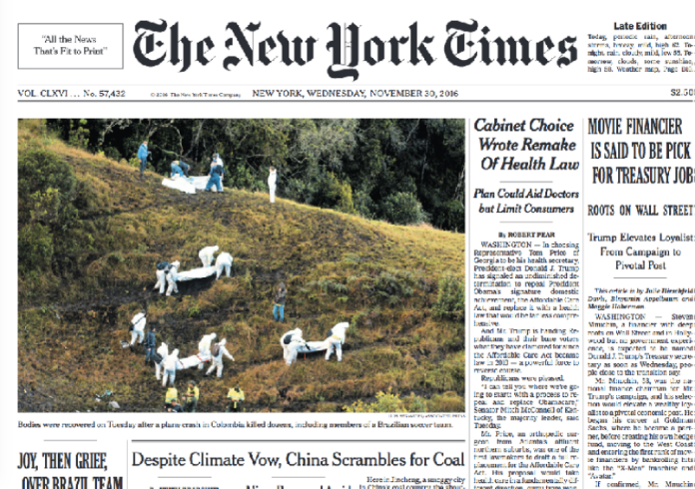
The mental model is that the photograph is embedded in the text of the document…

but in the computer model the photograph is an independent file, which could be changed separately.

User Interface Design
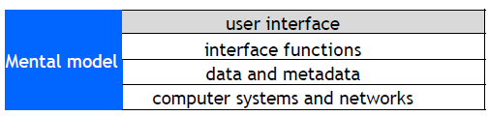

- The user interface is the appearance on the screen and the actual manipulation by the user.
  - Fonts, colors, logos, keyboard controls, menus, buttons
  - Mouse control, touch screen, or keyboard control
  - Conventions (e.g., "back", "help")
- Example: to leave full screen
  - Keyboard: escape key, control-F Mouse/touch:

- Examples of design choices
  - Screen space utilization in Adobe Reader.
  - Number of snippets per page in web search.

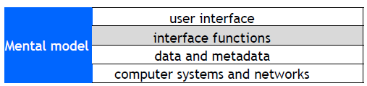
Interface Functions
- The interface functions determine the actions that are available to the user:
  - Select part of an object
  - Search a list or sort the results.
  - View help information
  - Manipulate objects on a screen.
  - Pan or zoom.
- There may be alternative user interface designs for the same interface functions, for example:
  - Different versions of the MS Windows desktop have most of the same interface functions, but different user interface designs.
  - Applications that run on both Windows and Macintosh computers support a one-button mouse (Macintosh) o a two-button mouse (Windows).

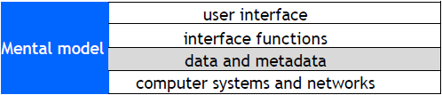
Data and Metadata
- The interface functions and the interface design provide an interface to the data and metadata stored by the computer system.
- The desktop metaphor has the concept of associating a file with an application. This requires a file type to be stored with each file:
  - extension to filename (e.g., .txt, .pdf)
- Inexperienced clients sometimes ask for interface features that require additional data or metadata.

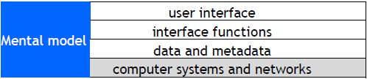
Computer Systems and Networks
- The performance, reliability and predictability of computer systems and networks are crucial factors.
- Examples
  - Instantaneous response time is essential for mouse tracking.
  - Response time for transactions may determine the action taken, e.g., approve credit card if no reply within five seconds.
- Response time requirements
  - 0.1 sec – the user feels that the system is reacting instantaneously.
  - 1 sec – the user will notice the delay, but his/her flow of thought stays uninterrupted.
  - 10 sec – the limit for keeping the user's attention focused on the dialogue.
- As computer systems improve, users have got more demanding. A response time that is good enough today, may not be good enough five years from now.

Principles of User Interface Design
- User interface design is partly an art, but there are general principles
  - Consistency -- in appearance, controls, and function.
  - Feedback -- what is the computer system doing? Why does the user see certain results?
  - Users should be able to interrupt or reverse actions.
  - Error handling should be simple and easy to comprehend.
  - Skilled users should be offered shortcuts; beginners should have simple, well-defined options.
  - The user should feel in control.
- Avoid the Fancy
- Simple is Good

Interface Design: Menus
- Easy for users to learn and use
- Certain categories of error are avoided
- Enables context-sensitive help
- Major difficulty is structure of large number of choices
  - Scrolling menus (e.g., states of USA)
  - Hierarchical
  - Associated control panels
  - Menus plus command line
- Users prefer broad and shallow to deep menu systems

Help System Design
- Help system design is difficult
  - Must prototype with mixed users
  - Must have many routes to same information
- Categories of help:
  - Overview and general information
  - Specific or context information
  - Tutorials (general)
  - Cook books and wizards
  - Emergency ("I am in trouble ...")
- Help systems need experienced designers. Schedule plenty of time for development and user testing.

Information Presentation
- Simple is often better than fancy
- Text
  - precise, unambiguous
  - fast to compute and transmit
- Graphical interface
  - simple to comprehend/learn, but icons can be difficult to recognize
  - uses of color
  - variations show different cases

Command Line Interfaces
- Problems with graphical interfaces
  - Not suitable for some complex interactions
  - May be slow for skilled users
  - Difficult to build scripts
  - Only suitable for human users
- User interacts with computer by typing commands (e.g., Linux shell script)
  - Allows complex instructions to be given to computer
  - Facilitates formal methods of specification & implementation
  - Skilled users can input commands quickly
  - Unless very simple, requires learning or training
  - Can be adapted for people with disabilities
  - Can be multi-lingual
  - Suitable for scripting/ non-human clients

Device-Aware Interfaces
- Interfaces must take into account physical constraints of computers and networks:
  - How does a desk-top computer differ from a laptop?
  - What is special about a smartphone?
  - How do you make use of a touch-sensitive screen?
  - What works well with a digital camera?
- Constraints that the interface must allow for:
  - performance of device (e.g., fast or slow graphics)
  - limited form factor (e.g., small display, no keyboard)
  - connectivity (e.g., intermittent)

Networks
- Operations that transfer data over the network have unpredictable response times and are subject to delay.
  - Large data transfers should run asynchronously in a separate thread.
  - Provide visual feedback to indicate that the operation is in progress.
  - Provide a way for users to cancel long running data transfers

Smartphones and Tablets: Screen Size
- Smartphones and tablets have small screens. Every small area is important.
  - There is big difference in screen size between a small smartphone and a large tablet.
  - There may be different layouts or even different version for different screens.
  - Apps need to have different layouts for portrait and landscape.
- Apps need to be tested with a full range of screen sizes and orientations.
- Some apps may be optimized for a large screen.
- Use a simulator to see how your app looks on various devices.

Smartphones: Accessibility
- Smartphones have small displays and small virtual keyboards. Some apps rely on speech or other sound signals.
  - People with poor eyesight, color blindness, hearing loss, or clumsy fingers may have difficulty using your applications.
  - Android and iOS provide numerous accessibility features and provide online advice about how to build accessible apps.
  - For your user testing try to find people who do not have perfect eyesight, hearing, etc. Have testers of various ages. Older people are often less able to use touch sensitive screens.

Screen Size: Responsive Web Design
- Responsive web design adjusts how web pages are viewed based on the size of the screen, or other characteristics of the device or browser used to view the page.
- Media queries in CSS (Cascading Style Sheet) allow the page to use different CSS style rules based on characteristics of the device the site is being displayed on, e.g., the width of the browser window.
- For example. You develop a web site using a laptop computer. How will it look on a smartphone?

Responsive Web Design
- Browsers such as Chrome, Firefox, and Safari have options that allow you to see how your site would appear on other devices.
- The ideal:
  - A single web site adapts to any device by using a mix of flexible grids and layouts, and careful use of CSS media queries.
- In practice:
  - Mobile devices, such as smartphones, are so different from regular computers that it is extremely difficult to create a web site that works well on all devices.
- For example:
  - Less content can be displayed on a small screen than on a large screen.
  - Smartphones are usually used in portrait; computer screens are landscape.
  - A touch screen has different characteristics from a mouse, e.g., the user cannot hover over a menu item.
  - A virtual keyboard needs screen space.

- Major web sites have several versions of the site for different devices.
- They identify the user’s device and automatically provide the version designed for that type of device.
- This Safari example shows the New York Times mobile version of the web site on a small iPhone.
- The next slide, from Firefox, shows the same page on a laptop computer.

User Interface Design: Navigation
- Getting the navigation right is central to the user experience. Applications consist of one or more pages (web) or screens (mobile apps).
  - Web: loading a new page uses the network and is therefore slow
  - Smartphone or tablet: loading a new screen is usually instantaneous
- The first step in user interface design is to choose what pages or screens to use.
  - What functionality is provided on each screen?
  - How are the screens organized?
  - How does the user know what screens are available?
  - How does the user move between screens?

User Interface Design: Organization of Pages and Screens
- The organization of the pages must match the user’s mental model. Keep it simple.
- Organization of pages in a web application.
  - The basic building block of the web is a hyperlink. This allows any page to link to any other page. This is flexible, but can lead to confusing applications.
  - Many web sites use a hierarchical tree structure.
  - When a user leaves a page, the state is lost unless explicitly saved.

Organization of screens in a mobile app
  - Both Android and iOS encourage the use of a stack based architecture.
  - When a user leave a screen, the state is pushed onto a stack and is available when the screen is next used.
  - Indicate to the user what pages are available and how to reach them.

Navigation: User Testing
- Before building an application, test the navigation.
  - Create simple mock-ups, e.g., rough sketches.
  - Create a large number of simple scenarios. They should show all the main paths through the application, including user mistakes, system problems, etc.
  - Step through the scenarios with the client and potential users.
- Later in the development process, these scenarios can be used for user interface design, program design, and all forms of testing.
- It is much easier to make changes in the basic navigation before beginning the detailed user interface design and implementation.

Mobile Apps: Development Environments
- App development is complex. Most apps are built using development environments such as Android Studio and Apple’s Xcode.
- There are good tutorials and good documentation online. I strongly recommend that you work through a tutorial before attempting to build a real app.
- If you are new to Android or iOS development allow plenty of learning time.
- For your project try to have several team members with previous experience of the development environment that you are using.
- These environments are moderately flexible for user interface design. They support a variety of ways to navigate, user interface objects, etc. But they have limitations (e.g., iOS does not have a radio button).
- To build a good user experience, understand and adopt the style of the development environment.
  - Users will be familiar with the style of interface from other apps.
  - The interface objects are well designed with good technical implementation.
  - The objects are intended to be used on a variety of devices.
  - When new versions of the operating systems are released, the designs will need a few modifications.

Model-View-Controller: The View
- Most modern development environments use one of the many variations of the Model-View-Controller architecture.
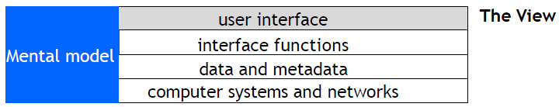
- In the Model-View-Controller architecture, the user interface is called the View.
  - Many of the interface functions are implemented by user interface widgets that are provided by the development environment.
  - The development environment may also provide recommended styles for the user interface, e.g., fonts, graphical elements.

Model-View-Controller: The Controller
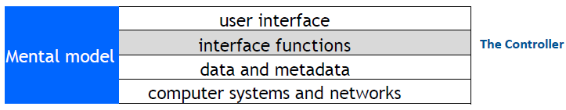
- In the Model-View-Controller architecture, the interface functions are invoked by the Controller.
- The Controller manages the flow of control of the whole user interface and connects the View to the Model.

Model-View-Controller: The Model
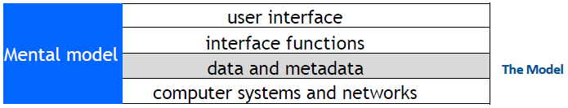
- In the Model-View-Controller architecture, the data and metadata are maintained by the Model.
- The Model also manages the logic of all parts of the system that are not part of the user interface.

Mobile Apps: the Design Challenge
- How do you design a user interface with no instructions, no user manual, no training?
- Look: Characteristics of the appearance that convey information.
- Feel: Interaction techniques that are intuitive and provide satisfactory experience.
- Metaphors and mental models: Mental models and metaphors. But there may not be an intuitive model.
- Navigation rules: How to move among data, functions, and activities in a large space.
- Conventions: Familiar aspects that do not need extra training – good for users, good for designers, e.g., scroll bars, buttons, gestures, help systems, sliders.

Mobile Apps: Development Environments
- Development environments include standard classes that provide templates for navigation and the layout of screens.
- Designs that incorporate these classes can use services, APIs, etc. that the operating environment provides.
- This example uses an iOS TableViewController.
- Because the length of tables can be very long, iOS implements a TableViewController in a manner that makes efficient use of storage and processing power.

Mobile Apps: Conventions
- Development environments encourage consistent apps.
- You may never have used this app, but look at how many aspects feel familiar.


Design Tensions in Web and Mobile Applications
- Designers wish to control what the user sees, but users wish to configure their own environments.
  - Client computers and network connections vary greatly in capacity.
  - Client software may run on various operating systems, which may not be the current version.
  - Accessibility requires that designers do not take control of parameters such as font size.
- Be explicit about the assumptions you make about the user's computer, web browser, etc. In using style sheets, such as CSS, avoid over-riding user preferences.

Usability and Cost
- User interface development may be a major part of a software development project.
  - Good usability may be expensive in hardware or special software development.
  - Costs are multiplied if a user interface has to be used on different computers or migrate to different versions of systems.
- Design users interfaces that can be built with standard tools:
  - Web browsers provide a general-purpose user interface where others maintain the user interface software.
  - Use the standard classes that the development environment provides.

The Analyze/Design/Build/Evaluate Loop
- Whenever possible, the design and evaluation should be done by different people.
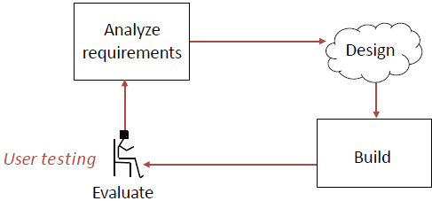

Evaluation
- If your system has users, the schedule should include time for user testing and time to make changes after the user testing is completed.
- When to do evaluation
  - Iterative improvements during development.
  - Making sure that a system is usable before launching it.
  - Iterative improvements after launch.
- Methods of evaluation
  - Empirical evaluation with users (user testing)
  - Measurements on operational systems
  - Analytical evaluation: without users
- How do you measure usability? Usability comprises the following aspects:
- Effectiveness
  - The accuracy and completeness with which users achieve certain goals
  - Measures: quality of solution, error rates
- Efficiency
  - The relation between the effectiveness and the resources expended in achieving them
  - Measures: task completion time, learning time, number of clicks
- Satisfaction
  - The users' comfort with and positive attitudes towards the use of the system

Evaluation with Users
- Stages of evaluation with users:
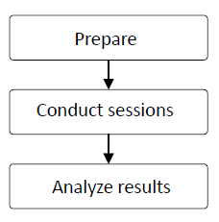
- User testing is time-consuming, expensive, and essential

Evaluation with Users: Preparation
- Determine goals of the usability testing
  - “Can a user find the required information in no more than 2 minutes?”
- Write the user tasks
  - “Given a new customer application form, add a new customer to the customer database.”
- Recruit participants
  - Use the descriptions of users from the requirements phase to determine categories of potential users and user tasks

Usability Laboratory
- Concept: monitor users while they use system

Evaluation with Users: Sessions
- Conduct the session:
  - Usability Lab
  - Simulated working environment.
- Observe the user:
  - Human observer(s)
  - Video camera
  - Audio recording
- Inquire satisfaction data.

Evaluation: Number of Users
- A great deal can be learned from user testing with a small number of users, even as few as five people.
  - Try to find different types of user (young/old, experienced/beginners, etc.).
  - Prepare carefully.
  - Combine structured tests with free form interviews.
  - Have at least two evaluators for every test.

Results Analysis
- Test the system, not the users
- Respect the data and users' responses. Do not make excuses for designs that failed.
- If possible, use statistical summaries.
- Pay close attention to areas where users:
  - were frustrated
  - took a long time
  - could not complete tasks
- Note aspects of the design that worked and make sure they are incorporated in the final product.

Project: Methodology
- The next few slides are from a presentation
- How we’re user testing:
  - One-on-one, 30-45 min user tests with staff levels Specific tasks to complete
  - No prior demonstration or training
  - Pre-planned questions designed to stimulate feedback
  - Emphasis on testing system, not the stakeholder!
  - Standardized tasks /questions among all testers
- Types of questions we asked:
  - Which labels, keywords were confusing? What was the hardest task?
  - What did you like, that should not be changed? If you were us, what would you change?
  - How does this system compare to your paper based system
  - How useful do you find the new report layout? (admin)
  - Do you have any other comments or questions about the system? (open ended)

A Project: Results
- What we’ve found: Issue #1, Search Form Confusion!
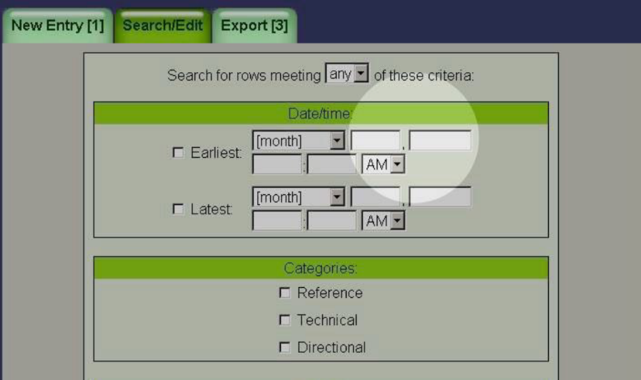

- What we’ve found: Issue #2, Inconspicuous Edit/ Confirmations!

- What we’ve found: Issue #3, Confirmation Terms

- What we’ve found: Issue #4, Entry Semantics

- What we’ve found: #5, Search Results Disambiguation & Semantics

Evaluation based on Measurement
- Basic concept: log events in the users’ interactions with a system
- Examples from a Web system
  - Clicks (when, where on screen, etc.)
  - Navigation (from page to page)
  - Keystrokes (e.g., input typed on keyboard)
  - Use of help system
  - Errors May be used for statistical analysis or for detailed tracking of individual user.
- Analysis of system logs
  - Which user interface options were used?
  - When was the help system used?
  - What errors occurred and how often?
  - Which hyperlinks were followed (click through data)?
- Human feedback
  - Complaints and praise
  - Bug reports
  - Requests made to customer service

Refining the Design based on Evaluation
- Do not allow evaluators to become designers
- Designers are poor evaluators of their own work, but know the requirements, constraints, and context of the design:
  - Some user problems can be addressed with small changes
  - Some user problems require major changes
  - Some user requests (e.g., lots of options) are incompatible with other requests (e.g., simplicity)
- Designers and evaluators need to work as a team

